­­­­­­

Fitness 365

Name – Chitransh Sisodiya

Employee Id – 8108616

Table of Contents

1. Introduction
   1. Introduction to the Project
   2. Objective of the Project
2. Software Project Development Methodology
3. Design
   1. Data Flow Diagram
   2. Data Base Design
   3. Sequence Diagram
4. Folder Structure
5. ScreenShots

Introduction to the Project

This project is designed to facilitate a gymming and fitness center to automate its operations of keeping records and store them in form of a large and user friendly database further facilitating easy access to the personnel.

Data Redundency is also a great issue in such kind of system. ”Redundency” means repititon; Thus data modified or updated at a particular place may not be data modified or updated at the other related place which may create inconsistencies in data handling, Destroys Data Integrity and creates confusion for the owner.

Objective of The Project

# What was the Problem?

* Existing system was manual.
* Time consuming as data entry which include calculations took lot of time.
* Searching was very complex as there could be 100’s of entry every year.
* The Project was made in order to effectively and efficiently cater to requirements of the fitness center. Generally, In order to structure these tasks Separate Registers are maintained. This whole process thus becomes quite cumbersome for them to control manually.
* This Manually Managed system of the store was also heavily proned to data loss due to certain causes Misplacement of Registers, Destruction of Registers, Unauthorized access to registers etc. which can bring in disasterous Consquences.
* The cost of maintaince of data and records of occurrence of transactions is very high.
* Searching a particular data specific to particular requirements is also very tedious in such system. In order to retrieve records, The responsible person needs to manually locate the appropriate register and locate the appropriate placement of that particular record which may be very time consuming.

Software Project Development Methodology

* **Topic Understanding:**

It is vital that the field of application as introduced in the project may be totally a new field. I carefully went through the project requirements to identify the requirements of the project.

* **Entity Break –Up of The System:**
* Identify The Various Entities in The System.
* List Them in The Right Hierarchy.
* Identify Their Priority of Development.

Different Entity in Computerised System

* Admin
  + Admin Id
  + Password
* Employees
  + Employee Id
  + Employee Name
  + Employee Type
  + Employee Image
  + Address
  + Gender
  + Phone No
  + Is Active
* Members
  + Member Id
  + Member Name
  + Member Image
  + Membership Type
  + Membership Start Date
  + Address
  + Gender
  + Phone No
  + Is Active
* Equipments
  + Equipment Id
  + Equipment Name
  + Equipment Detail
  + Equipment Type
  + Quantity

Design

Data Flow Diagram

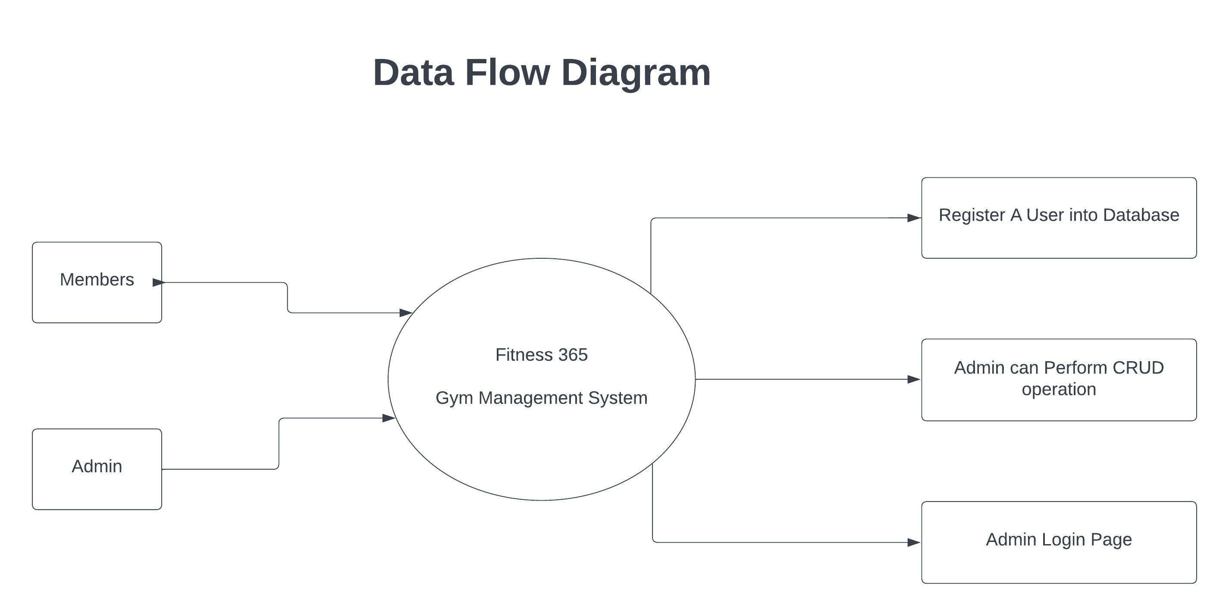

Data Base Design

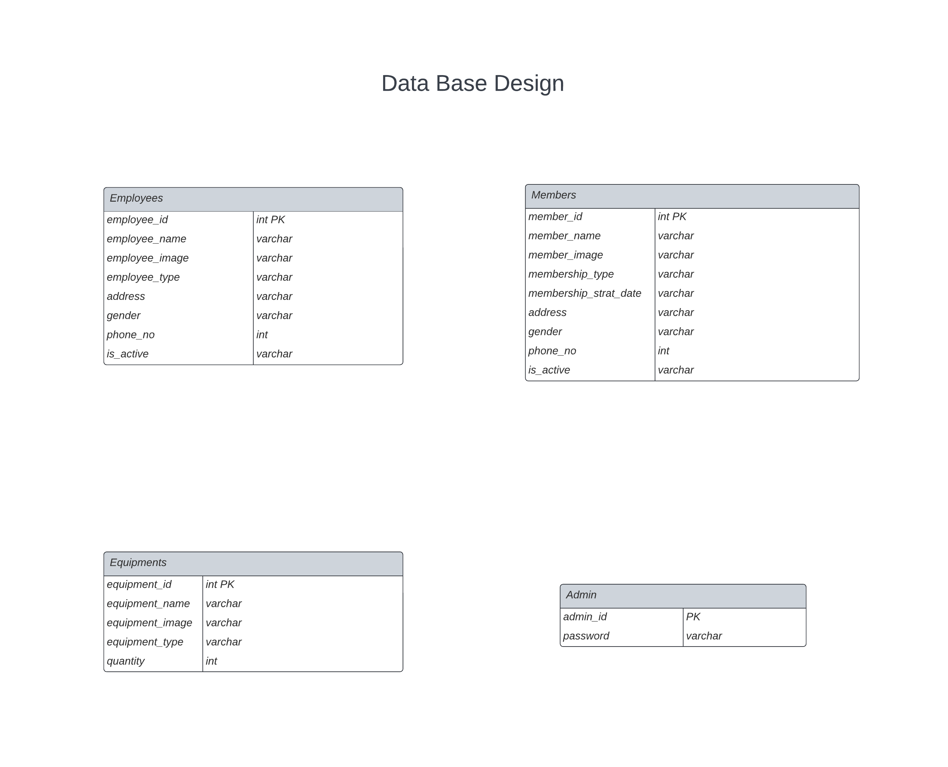

Folder Structure

Angular Folder Structure

* Src
  + Index.html
  + App
    - Class
      * Admin.ts
      * Employee.ts
      * Equipment.ts
      * Member.ts
* Dashboard Component
* EditDelete
  + Add-employee Component
  + Add-equipment Component
  + Add-member Component
  + Employee-edit Component
  + Employee-delete Component
  + Equipment-edit Component
  + Equipment-delete Component
  + Member-edit Component
  + Member-delete Component
  + Register-member Component
* Employees Component
* Equipments Component
* Home Component
* Login-signup Conponent
* Members Component
* Services
  + Services.ts
* App.component.css
* App.component.html
* App.component.spec.ts
* App.component.ts
* App.module.ts
* App-routing.module.ts

Spring Folder Structure

* Src
  + Main/java/com/example/demo
    - Entity
      * Admin.java
      * Employee.java
      * Equipment.java
      * Member.java
    - Repository
      * AdminRepository.java
      * EmployeeRepository.java
      * EquipmentRepository.java
      * MemberRepository.java
    - Controllers.java
    - Fitness365Application.java

ScreenShots

Home Page

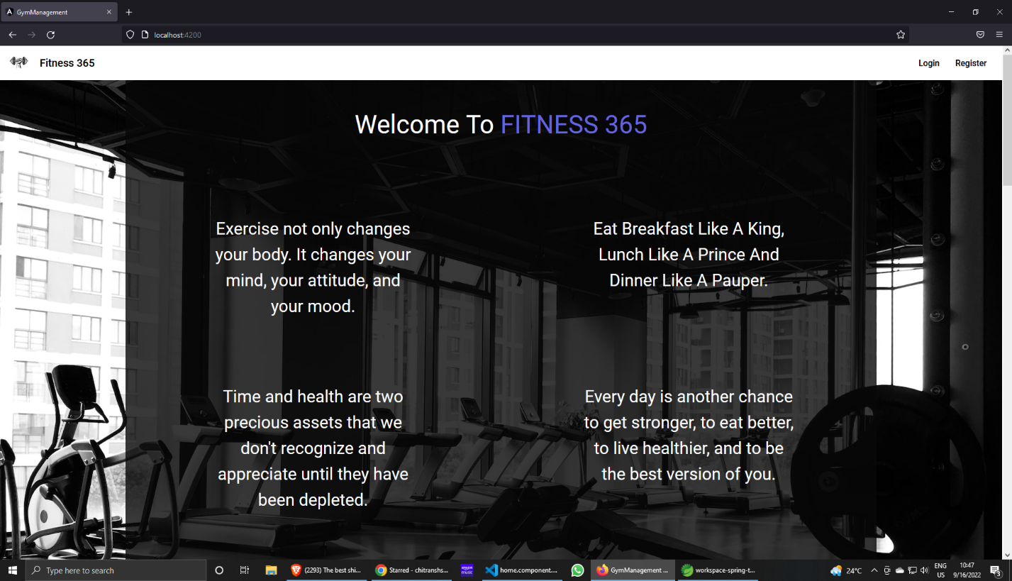

Register User

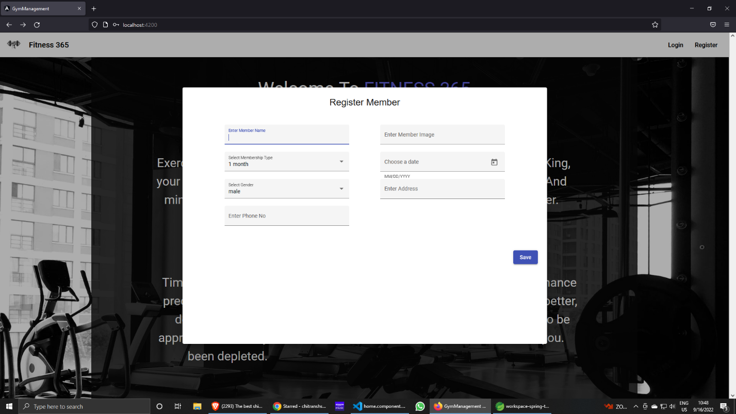

Login Page

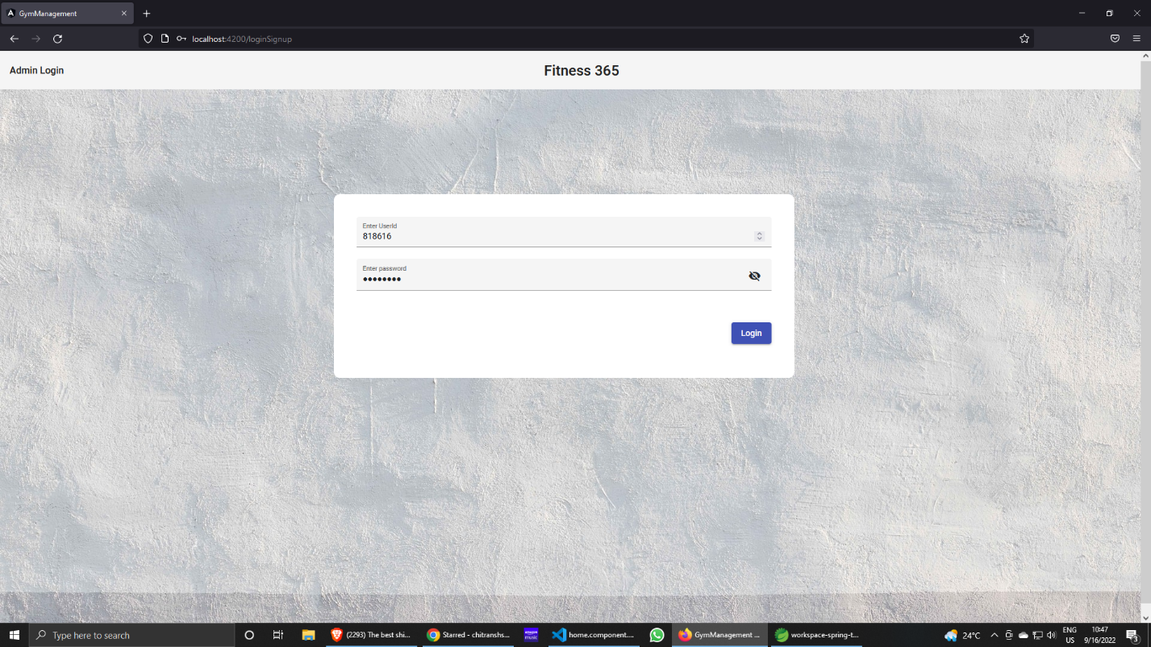

Dashboard

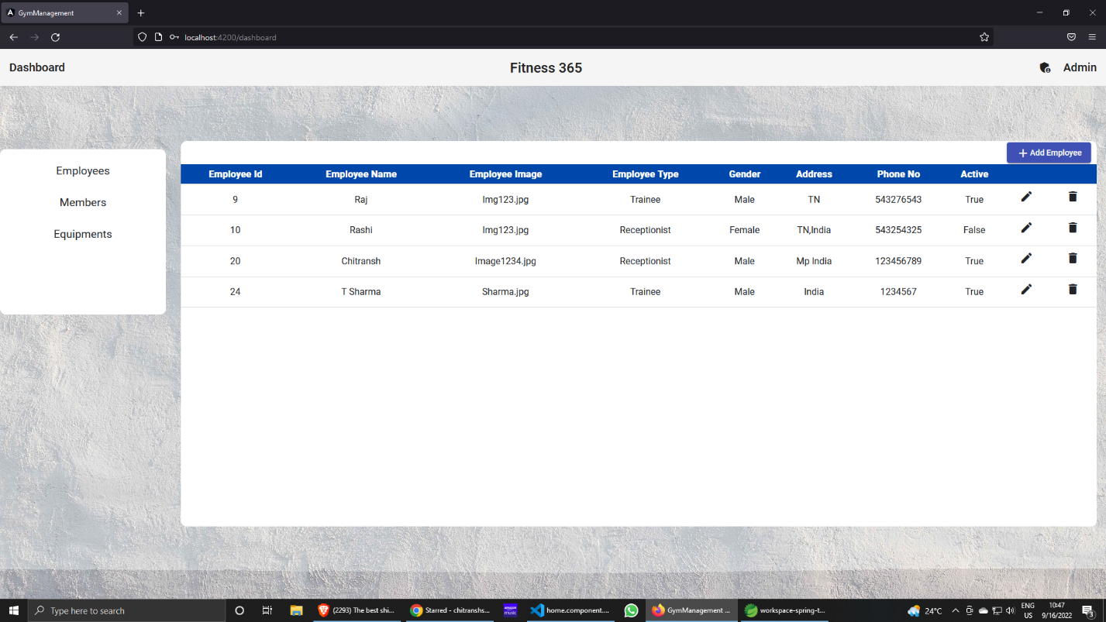

Add-Employee

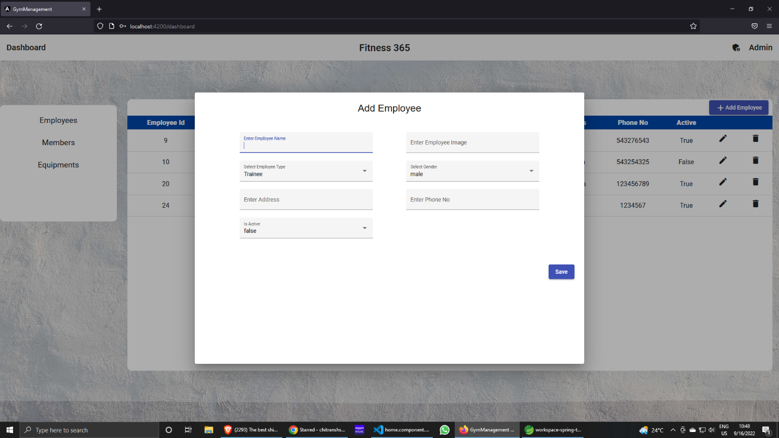

Edit Employee

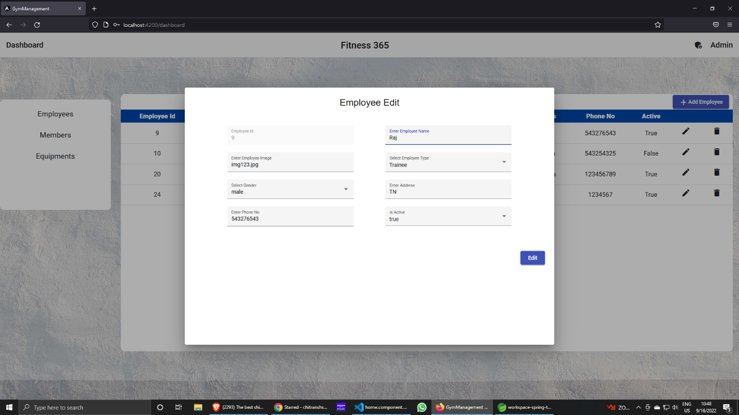

Delete Employee

